**Nielsen : Predicting the COVID-19 behavioral reset**

After driving huge global consumer behavior shifts in the first quarter of 2020, consumers’ shopping habits are no longer reflecting what was reported in the news. The correlation between news cycle, and what people tend to purchase at the initial state of the pandemic (hand sanitizers, toilet paper, cleaning products, food staples) has faded.

But, the purchase of fast-moving consumer goods (快消品 FMCG, AKA CPG consumer packaged goods) still remains steady, with exceptions of short period peaks after business re-openings in various countries. The pandemic purchase decisions now are driven by four more factors : a) a basket reset b) a homebody reset c) a rationale reset d) an affordability reset

Businesses should seize the opportunity and learn to predict how purchase patterns are likely to pivot / shift.

1. **Purchase habits now driven by**
2. A basket reset: To react to the new regulations and public health measures, consumers have new requirements to meet, with emerging basket essentials now accounting for both old and new necessities.

* This is a critical window of opportunity for companies to translate pandemic-minded consumption into continued, essential routine. ( offer face masks products, pivot to e-retail)

1. A homebody reset: In-home spending is prioritized as business restrictions pertain.

* Obviously this finding varies by countries. As far as I know, a lot of my friends in Canada and the U.S. are still working from home. So their spending is heavily focused on setting up at-home workstations.
* It’s been confirmed by global measures that many homebound routines are here to stay.
* Do-it-yourself mindset: flour, hair dye, canning supplies, sushi wrap
* Companies that can intelligently utilize the discovery of DIY behaviors, will succeed in empathizing with today’s customer interests in creative, cost-conscious and safe consumption. Should respond with affordable, accessible and branded take-home experiences.

1. A rationale reset: Consumers are rethinking how and why they should spend their dollars. Overall consumer confidence decreases as people avoid spending on luxury, travel and other discretionary activities.

* Brands that can identify the new use cases of consumers who seek comfort and reward in small FMCG purchases, will benefit.

1. An affordability reset: Due to the impact of unemployment and the upcoming economic crisis, consumers become more conscious, risk averse.

* The recent lack of ‘usual’ promotional activity leads to perhaps a historic moment where companies can reset their approach to affordability in ways that offer greater efficiency than before.

“The unique macro conditions of a pandemic driving economic recession are forcing consumers to rethink how they shop and what they buy. The implication for brands trying to fulfil new needs of consumers is that they must be very focused and very fast in their response. ”

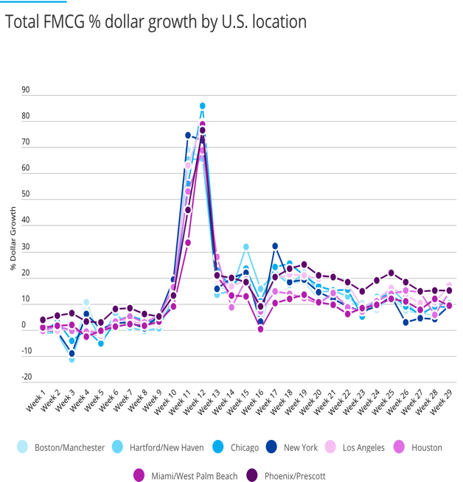

FMCG% dollar growth for 2020 vs 2019

Note here when analyzing plots, we typically go from a higher-level (overall US) 🡪 a lower-level (focus on each local area)

Conclusion: 1) Overall in the U.S., the correlation between virus transmission (# confirmed cases) and purchase behavior is fading. We only see a peak in mid-march during the initial lock-downs. But then during the recent few weeks, sales growth for LA and Hartford were very similar. Meanwhile cases confirmed in LA were 8 times those diagnosed in the whole Connecticut. 2) Locally, we see small upticks when business just reopened in early May, but the impact is short lived, lasting for only 2 weeks.

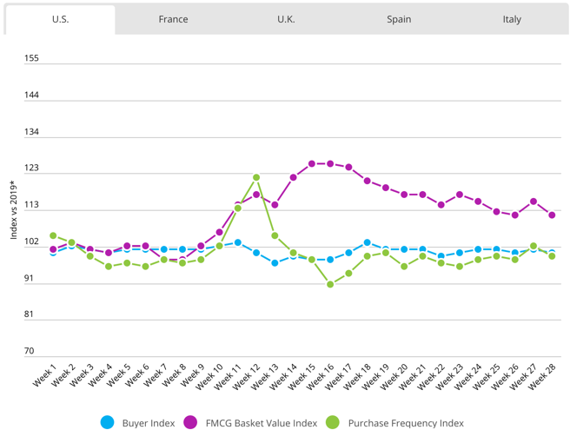FMCG Basket Size Stabilizes in recent weeks across the markets (Consumer dynamics by market)

Note here index 100 represents behavior in 2020 is the same as in 2019, index 111 means 11% higher

Conclusion: 1) Both purchase frequency and average size of the basket has come down from the peak COVID-19 period, in which we can anticipate all consumers will re-prioritize what to buy. Reflects a consumption reset.

Total FMCG basket size index by Channel and market

Conclusion: 1) E-Commerce basket size of U.K. consumers was consistently 130 – 160% higher than measures in 2019. (index 260)

Read as use 2019 U.S. adults who travelled by flight as index, they are now 21% more likely to buy artisan bread (index121)

Good example of how visualization can be both interesting and intuitive. It shows how significance of small FMCG may be redefined as a fulfillment of the missing leisure spending.

1. **Socio-economic consequences 🡪 polarization of consumers**

Ongoing economic recession has also polarized consumer groups into constrained spenders, and insulated spenders.

|  |  |  |
| --- | --- | --- |
|  | constrained spenders | insulated spenders |
| basket reset | spend to survive, avoid unnecessary stockpiling | more mindful as the |
| homebody reset | pivot to self-serviced products to avoid costs | more flexible, explore and try new, self-serviced products to personalize and amplify care and meal solutions at home |
| rationale reset | more mindful about each purchase | can no longer enjoy travel and other entertainment, so they now seek luxuries in FMCG |
| affordability reset | may start to abandon brands, package formats and retailers to save on costs | price becomes more of a purchase driver to consumers as product availability improves |

Reference:

<https://www.nielsen.com/us/en/insights/report/2020/predicting-the-covid-19-behavioral-reset/?utm_source=linkedin&utm_medium=organicsocial&utm_content=nielsen&utm_campaign=Global+Connect>